Software Engineering project Car Rental Management System

Abilova Lira

**Project Description**

The Car Rental Management System is crafted to optimize how customers, vehicles, and staff interact. It organizes key information across several categories: Customers, Cars, Bookings, Payments, Rental Manager, Maintenance Reports, and Rental Staff - to promote efficient operation of rental services. The system simplifies the reservation and payment process for clients, while empowering managers and staff to deliver superior service. Essential for adapting to the fast-paced car rental market, this system plays a crucial role in achieving customer satisfaction and enhancing business procedures.

**ERD**

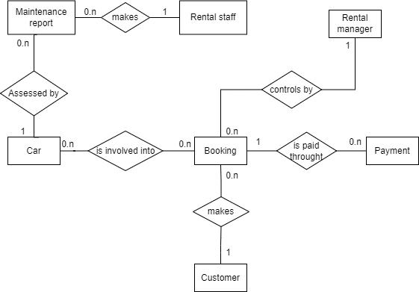

**Data Dictionary**

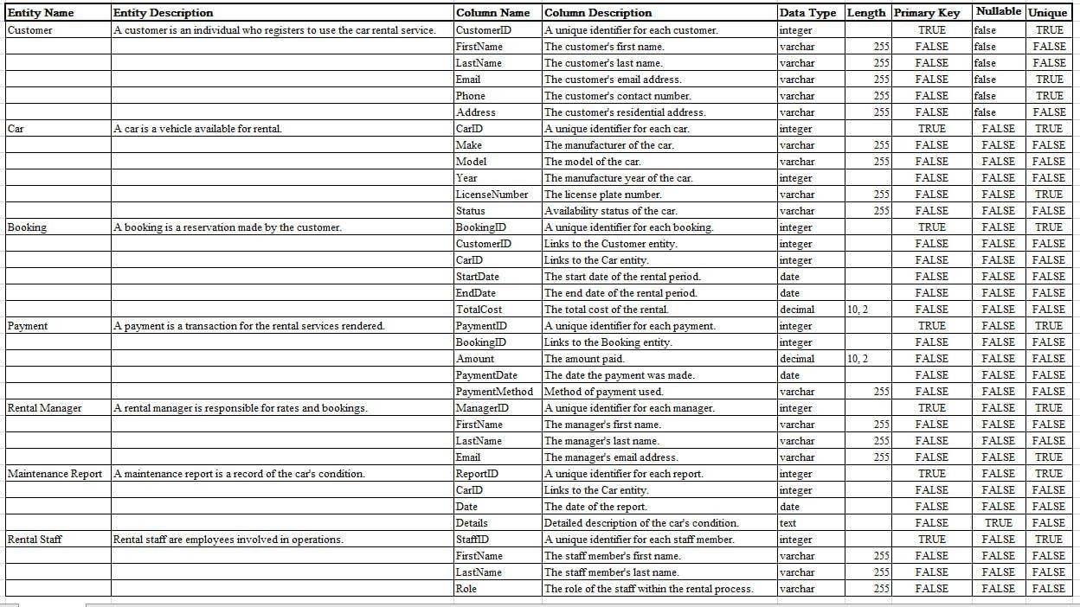

**Context Diagram**

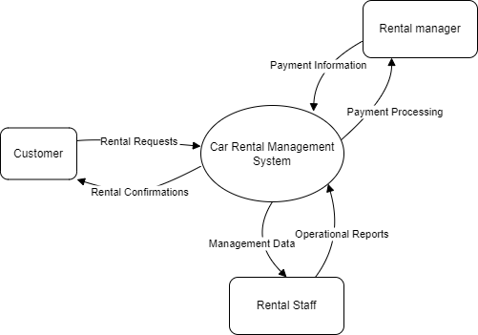

**Event list**

1. Customer registers personal details to car rental system
2. Customer Searches for available cars
3. Rental staff confirm reservation details
4. Rental manager updates rate and booking details
5. Customer completes payment
6. Rental period begins
7. Rental staff conduct and record car examination upon return
8. Customer receives booking and payment confirmation

**DFD Level 1**

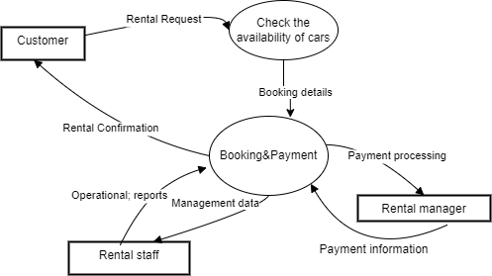

**DFD level 2**

